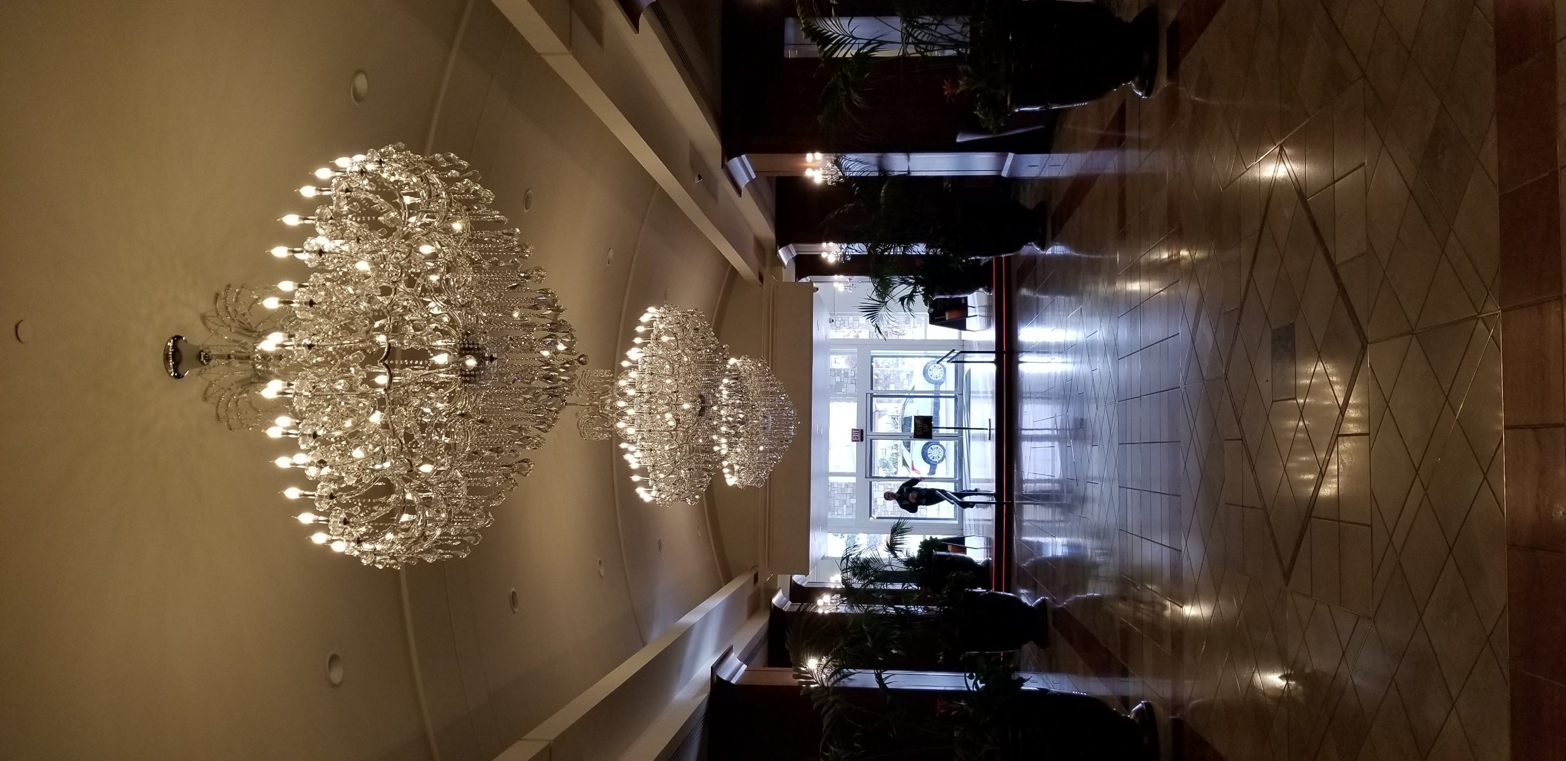
You are invited to participate in the 2019 Rocky Mountain PI Conference, held at the Antlers Hotel in beautiful Colorado Springs, Colorado, July 24-26, 2019.
To better realize your return on investment, we have provided many options. You are now able to tailor your vendor and/or sponsorship advertising to best reflect your company’s special requirements! Note that our vendor area will be in the same area that the food and beverages are located, for maximum exposure. Vendors are provided with wifi and electricity.
Cocktail Sponsorship: $1250.00 (includes signage on tables in cocktail room, notation in Conference Notebook and Website, and a manned table for 3 days) Only 1 available
Manned Table: $350.00 (includes internet and 2 chairs) 7 available (additional tables can be had for $75.00 after initial manned table selection)
Break sponsorship: $300.00 (includes an easel with a placard next to the food and beverages, with sponsor’s name on it, and a listing in the notebook) 6 available, 2 per day
Advertising space/ Website: $600/6 months, or $900/year (includes a rotating website banner on the front page of PPIAC.org and up to 3 changes)
Advertising space/ Conference Notebook: $75/quarter page color ad, $150/half page color ad, $275/full page color ad)
Advertising Space/ Association newsletter: $50/issue
Presentation time: $50.00 per 10 minute increment, between speakers, 2 per day (5 available)
Vendors are encouraged to bring their own extension cords.
Company Name/Contact Person
Address:______________________________________________________________________
Email address:______________________________________________________________________
Authorized by:________________________________________________________________________
Signature and Date:_____________________________________________________________________
Vendor options (please list all requested options)______________________________________________________________________
___________________________________________________________________________
Additional comments/questions, please email training@ppiac.org.
Please note that the vendor and sponsor slots are for all three days (the Pre-conference on July 24th, as well as July 25-26) and there are some advertising opportunities that are limited in number. All options are sold on a first come, first serve basis. There will be no holds placed on any prospects. PPIAC holds the right of refusal. Payment due upon submission of completed form. Submit completed form to training@ppiac.org. Upon submission, an invoice will be emailed to you for payment.

